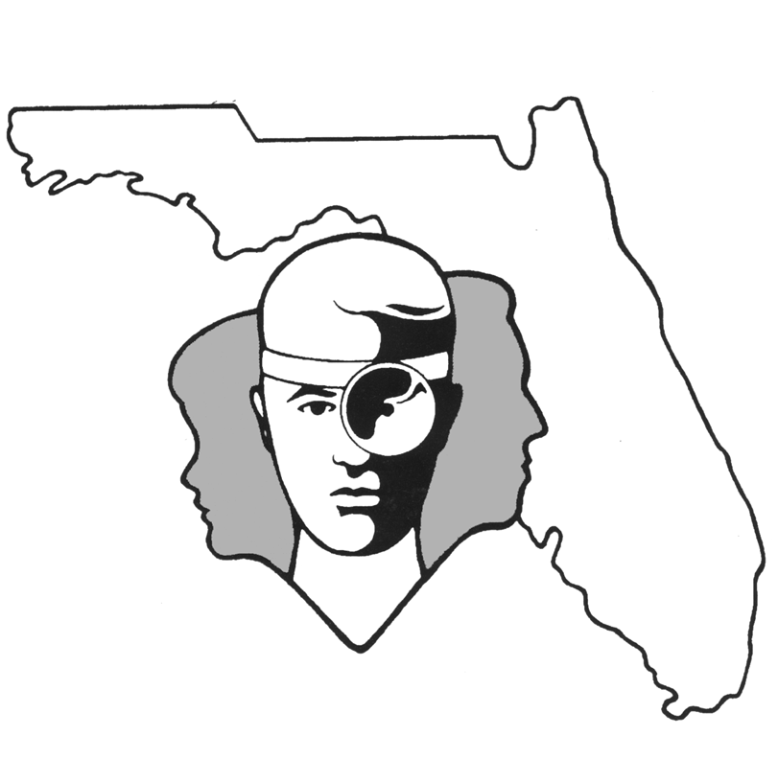
TALLAHASSEE EAR, NOSE & THROAT - HEAD & NECK SURGERY, P.A.

www.TallyENT.com Phone: (850) 877-0101

THYROIDECTOMY or PARATHYROIDECTOMY

The thyroid gland is located in the lower neck and has two lateral halves or “lobes” with a midline-connecting bit of tissue called the isthmus. The thyroid gland is responsible for controlling your metabolic rate. The parathyroid glands are closely involved, in terms of location and development, with the thyroid gland. There are four parathyroid glands, two on each side of the thyroid, and they control your calcium metabolism.

The most important nerves associated with the thyroid gland are the ones that control your breathing and your speech. They are called recurrent laryngeal nerves and superior laryngeal nerves. There are two on each side, with the most important ones being the recurrent laryngeal nerves and the less important ones being the superior laryngeal nerves.

The usual reason we recommend surgery on the thyroid is for suspicion of a tumor being present. Fortunately, these tumors are usually benign. Furthermore, even the malignant ones are extremely slow-growing so that waiting even months to have surgery has little effect on the cure rate. Cure rates are very high for most of these malignancies, as well.

On many occasions, we will recommend fine needle aspiration in the office. This allows sampling of tissue from the area of abnormality in your thyroid. Many times this can give a specific diagnosis and obviate the need for any surgery. On other occasions, it will enable us to diagnose a malignancy and counsel you better on your options. Unfortunately, there are occasions when the fine needle aspirate examination cannot give specific information, which would often mean that removal of at least the lobe of the thyroid and its isthmus would be necessary in order to make a specific diagnosis. This will be discussed in more detail below.

The minimal operation that we usually recommend is to remove the isthmus of the thyroid and one entire lobe. Occasionally we recommend removing the entire gland.

The main controversy about thyroid surgery is in situations where malignancy is found at the time of surgery when one lobe is removed. There are two schools of thought about this, and we will briefly explain both arguments.

Some surgeons feel, because the malignancies here are so slow-growing, that one should usually not take out more than one lobe. They feel that ancillary treatments and careful follow-up are always needed. They feel that the risk of taking out both lobes is too great without the evidence being strong enough that such as operation will result in a higher cure rate.

There is another group of surgeons, and we are among those, who often recommend removal of the other thyroid lobe when there is malignancy in the one lobe removed. Sometimes the decision is made at the time you are asleep, but other times, the pathologist cannot be sure about the malignancy until several days after the operation. We would then recommend a “completion thyroidectomy” at a later date.

We feel that the evidence is strong enough that there is a higher cure rate when both sides are taken out; and, if the surgeon is very careful, the complication rate is low enough. However, we acknowledge there is controversy in this area and feel that you should help with a final decision. Obviously, different opinions can be obtained from different surgeons, which make any absolute statements about this untenable.

In most situations, thyroid surgery is a very routine procedure and there are no problems. As with any surgical procedure there are possibilities of severe bleeding or infection. However, this chance should be on the order of 1 in 100, or smaller.

When the operation is performed only on one side (thyroid lobectomy), there is a small chance of injury to the main nerve (recurrent laryngeal nerve) that controls vocal cord movement. Again, the chance of this occurring in the usual situation is less than 1 in 100 and is usually temporary. Permanent injury to the recurrent laryngeal nerve is extremely rare unless there is cancer involved in the thyroid gland. This sort of injury would cause hoarseness, but usually improves dramatically with time. In other cases, it can also be improved with surgical procedures. Fortunately, permanent injury rarely occurs.

Occasionally, a much smaller nerve (superior laryngeal) to the voice box (larynx) can be injured. This happens slightly more frequently than the recurrent laryngeal nerve injury, but is usually only important to singers. They would notice inability to vocalize high pitches.

There is clearly more risk when the operation on the thyroid gland is performed on both sides (total or subtotal thyroidectomy). The reason for this is that if both recurrent laryngeal nerves are injured, not only would someone be hoarse, but it is most likely they would have difficulty breathing. Again, this is fortunately very unusual. When it does occur and a person has difficulty breathing, then temporary (almost never permanent) tracheostomy and sometimes further surgical procedures might be required.

Another risk of thyroid surgery, when it is performed on both sides, is a low calcium level in the blood. This happens on the order of 1 to 10% of cases, depending on whether or not cancer is present and whether or not previous surgery was performed. This can be treated medically, but is very bothersome and can sometimes be permanent.

To summarize, the main risks (often unusual and rarely permanent) of thyroid surgery when it is performed only on one side are:

1) Bleeding
2) Infection
3) Hoarseness

When thyroid surgery is performed on both sides, in addition to the above risks, there are risks of:

1) Inability to breathe without a tracheostomy (usually temporary; rarely permanent)
2) Low calcium levels in the blood (unusual; rarely permanent)

We encourage you to participate with us in making your own medical decision. As you can see from the above discussion, the need to remove the entire thyroid gland can often be a controversial subject. In some cases, it is clear that it should be performed. In other cases, it depends on whether or not a person is willing to risk problems with calcium and injury to both nerves to the larynx for the possibility of a slightly higher cure rate.

Please feel free to ask us more questions about this surgical procedure.

